H.T No
Regulations:
A18

Sreenidhi Institute of Science and Technology
(An Autonomous Institution)
Code No: 7EC01 Date: 02-Mar-2023 (FN)

B.Tech II-Year II- Semester External Examination, February/March-2023 (Supplementary)
DATA STRUCTURES (ME and ECE)

Time: 3 Hours Max.Marks:70

Note: a) No additional answer sheets will be provided.
b) All sub-parts of a question must be answered at one place only, otherwise it will not be valued.
c) Missing data can be assumed suitably.
Bloom's Cognitive Levels of Learning (BCLL)

Remember | L1 | Apply | L3 | Evaluate | L5
Understand | L2 | Analyze | L4 | Create | L6

Part - A Max.Marks:20

Answer all QUESTIONS.

 |  | BCLL | CO(s) | Marks
1 | Illustrate stack operations PUSH and POP with suitable example. | L4 | CO1 | [2M]
2 | Is linked list a linear data structure? Justify your answer with an example | L5 | CO2 | [2M]
3 | Write the preorder and postorder traversal for the following binary search tree.  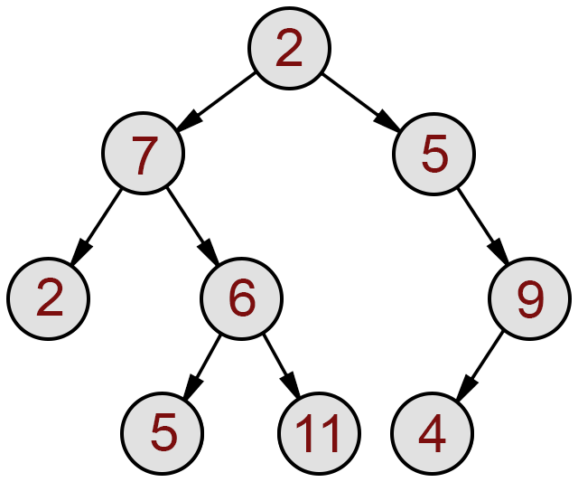 | L1 | CO3 | [2M]
4 | What is Heap? | L1 | CO4 | [2M]
5 | What is data encapsulation? Give example? | L1 | CO5 | [2M]
6 | Write syntax for function template. | L1 | CO6 | [2M]
7 | List out the applications of Queues | L1 | CO1 | [2M]
8 | Differentiate between weighted and unweighted graphs. Give examples. | L4 | CO3 | [2M]
9 | When do you call an object destructor? | L1 | CO5 | [2M]
10 | Explain Characteristics of Friend Function in C++. | L2 | CO6 | [2M]

Part – B Max.Marks:50
ANSWER ANY FIVE QUESTIONS. EACH QUESTION CARRIES 10 MARKS.

 |  |  | BCLL | CO(s) | Marks
11. | a) | What is the significance of queue? Explain the operations of queue with the help of an example. | L2 | CO1 | [5M]
 | b) | Develop a C program to implement the insert and delete operations on a Circular queue | L4 | CO1 | [5M]
12. | a) | Discuss the advantages of Double linked list over single linked list. | L2 | CO2 | [5M]
 | b) | Implement a C program to simulate Double linked list operations | L6 | CO2 | [5M]
13. | a) | How an AVL tree is different from Binary search tree and Construct a AVL tree and binary search tree for the given data: 63, 10, 19, 27, 18, 107, 99, 82 | L6 | CO3 | [5M]
 | b) | Explain Depth first search traversal algorithm. | L2 | CO3 | [5M]
14. | a) | Explain insertion sort technique with the help of example. | L2 | CO4 | [5M]
 | b) | Write a recursive C function to implement binary search and compute its  time complexity. | L1 | CO4 | [5M]
15. | a) | Explain polymorphism with an example. | L2 | CO5 | [5M]
 | b) | Write a C++ program to print the prime numbers from 2 to n. | L1 | CO5 | [5M]
16. | a) | Distinguish Function overloading and Function overriding. | L4 | CO6 | [5M]
 | b) | List different types of inheritance and Give an example of each. | L1 | CO6 | [5M]
17. | a) | Write an Algorithm to convert infix to postfix Expression. | L1 | CO1 | [4M]
 | b) | Write any two functions on Queue using Linked list. | L1 | CO2 | [3M]
 | c) | What are the types of graph in data structure? | L1 | CO3 | [3M]
18. | a) | What is Performance Analysis of an algorithm? | L1 | CO4 | [4M]
 | b) | Write Difference between Structured and OOP. | L1 | CO5 | [3M]
 | c) | Explain this pointer. | L2 | CO6 | [3M]

-- 00 -- 00 –

